**Code:**

import java.io.BufferedReader;  
import java.io.FileNotFoundException;  
import java.io.FileReader;  
import java.io.IOException;  
import java.security.KeyPair;  
import java.util.ArrayList;  
import java.util.HashMap;  
import java.util.Map;  
import java.util.Scanner;  
  
public class Main {  
 static class InvalidDets extends Exception{  
 public InvalidDets(String str){  
 super(str);  
 }  
 }  
  
 public static class Student{  
 Scanner s = new Scanner(System.*in*);  
 String reg;  
 int[] marks = new int[5];  
 int[] ques = new int[4];  
 void getdets() throws InvalidDets{  
 System.*out*.println("Give Reg no");  
 reg = s.nextLine();  
 System.*out*.println("Give the 4 attempted question numbers");  
 for (int i=0;i<4;i++){  
 int x = s.nextInt();  
 if (x>=1 && x<=10)  
 ques[i] = x;  
 else {  
 throw new InvalidDets("Wrong i/p");  
 }  
 }  
 System.*out*.println("Give quiz marks");  
 int x = s.nextInt();  
 if(x>=0 && x<=10)  
 marks[4] = x;  
 else  
 throw new InvalidDets("Wrong i/p");  
 }  
 }  
  
 public static void main(String[] args) throws Exception {  
 Scanner s = new Scanner(System.*in*);  
 HashMap<String,String> map = new HashMap<String,String>();  
 map.put("Q1","List");  
 map.put("Q2","Dictionary");  
 map.put("Q3","Exception Handling");  
 map.put("Q4","Functions");  
 map.put("Q5","OOPS");  
 map.put("Q6","Flow Control");  
 map.put("Q7","Files");  
 map.put("Q8","Date&Time");  
 map.put("Q9","Pandas");  
 map.put("Q10","Numpy");  
  
 FileReader fr =new FileReader("D:/AnswerKey.txt");  
 BufferedReader br = new BufferedReader(fr);  
 String line= "";  
 String[][] ques = new String[10][10];  
 int z=1;  
 while((line = br.readLine()) != null){  
 if(z%2 != 0)  
 z++;  
 else {  
 if (z == 2) {  
 ques[(z/2)-1] = line.split(",");  
 }  
 else if (z == 4)  
 ques[(z/2)-1] = line.split(",");  
 else if (z == 6)  
 ques[(z/2)-1] = line.split(",");  
 else if (z == 8)  
 ques[(z/2)-1] = line.split(",");  
 else if (z == 10)  
 ques[(z/2)-1] = line.split(",");  
 else if (z == 12)  
 ques[(z/2)-1] = line.split(",");  
 else if (z == 14)  
 ques[(z/2)-1] = line.split(",");  
 else if (z == 16)  
 ques[(z/2)-1] = line.split(",");  
 else if (z == 18)  
 ques[(z/2)-1] = line.split(",");  
 else if (z == 20)  
 ques[(z/2)-1] = line.split(",");  
 z++;  
 }  
 }  
 fr.close();  
 br.close();  
  
 int n = 5;//Number of students  
 Map<Integer, Map<String,Integer>> test = new HashMap<>();  
 Student[] stud = new Student[n];  
 Map<String,Integer> q1 = new HashMap<>(),q2= new HashMap<>(),q3= new HashMap<>(),q4= new HashMap<>(),q5= new HashMap<>(),q6= new HashMap<>(),q7= new HashMap<>(),q8= new HashMap<>(),q9= new HashMap<>(),q10 = new HashMap<>();  
  
 for(int i=0;i<n;i++){  
 System.*out*.println("For Student"+(i+1));  
 stud[i] = new Student();  
 stud[i].getdets();  
 String f;  
 System.*out*.println("Give file name");  
 f = s.nextLine();  
 fr = new FileReader("D:/"+f+".txt");  
 br = new BufferedReader(fr);  
 for(int x=0;x<4;x++)  
 stud[i].marks[x] = 0;  
 int j=-1;  
 while((line = br.readLine()) != null){  
  
 if(line.charAt(0) == 'Q')  
 j++;  
 else{  
 int q = stud[i].ques[j] - 1;  
 String ans[] = line.split(" ");  
 int m = 0;  
 for (int k=0;k<ans.length;k++){  
 for (int l=0;l<ques[q].length;l++){  
 if (ans[k].indexOf(ques[q][l]) != -1)  
 m++;  
 }  
 }  
 if(stud[i].marks[j] < 10)  
 stud[i].marks[j] += m;  
 }  
 }  
 for(int k=0;k<4;k++){  
 if (stud[i].ques[k] == 1)  
 q1.put(stud[i].reg,stud[i].marks[k]);  
 else if (stud[i].ques[k] == 2)  
 q2.put(stud[i].reg,stud[i].marks[k]);  
 else if (stud[i].ques[k] == 3)  
 q3.put(stud[i].reg,stud[i].marks[k]);  
 else if (stud[i].ques[k] == 4)  
 q4.put(stud[i].reg,stud[i].marks[k]);  
 else if (stud[i].ques[k] == 5)  
 q5.put(stud[i].reg,stud[i].marks[k]);  
 else if (stud[i].ques[k] == 6)  
 q6.put(stud[i].reg,stud[i].marks[k]);  
 else if (stud[i].ques[k] == 7)  
 q7.put(stud[i].reg,stud[i].marks[k]);  
 else if (stud[i].ques[k] == 8)  
 q8.put(stud[i].reg,stud[i].marks[k]);  
 else if (stud[i].ques[k] == 9)  
 q9.put(stud[i].reg,stud[i].marks[k]);  
 else if (stud[i].ques[k] == 10)  
 q10.put(stud[i].reg,stud[i].marks[k]);  
 }  
 }  
  
 System.*out*.println("Class wise marks");  
 int max=0;  
 for (int i=0;i<n;i++){  
 int tot =0;  
 System.*out*.println("Reg: "+stud[i].reg);  
 for (int j=0;j<5;j++){  
 tot += stud[i].marks[j];  
 if (j == 4)  
 System.*out*.println("Quiz marks = "+stud[i].marks[j]);  
 else  
 System.*out*.println("Question "+stud[i].ques[j]+" -> Marks = "+stud[i].marks[j]);  
 }  
 System.*out*.println("Total marks out of 50 = "+tot);  
 max = max+tot;  
 }  
 float avg = max/n;  
 System.*out*.println("Class average = "+avg);  
  
 test.put(1,q1);  
 test.put(2,q2);  
 test.put(3,q3);  
 test.put(4,q4);  
 test.put(5,q5);  
 test.put(6,q6);  
 test.put(7,q7);  
 test.put(8,q8);  
 test.put(9,q9);  
 test.put(10,q10);  
  
 System.*out*.println("Question wise class average:");  
 for (Map.Entry<Integer, Map<String,Integer>> entry : test.entrySet()){  
 System.*out*.println("Question "+entry.getKey());  
 int tot=0,count =0;  
 for (Map.Entry<String,Integer> e: entry.getValue().entrySet()){  
 count++;  
 tot += e.getValue();  
 }  
 float a = tot/count;  
 System.*out*.println("\tAvg = "+a+"\n");  
 }  
  
 }  
}

**Answer Key:**

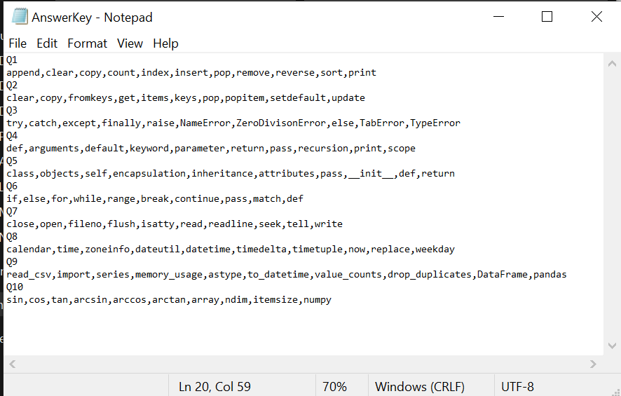

**S1(Answer sheet):**

Q1

List = [1,2,3,4]

List.insert(3, 12)

List.append((5, 6))

List.remove(5)

print(List)

Q3

try:

print("The entry is", entry)

r = 1/int(entry)

break

except:

print("Oops!", sys.exc_info()[0], "occurred.")

pass

Q4

def printme( str ):

"This prints a passed string into this function"

print str

return

Q6

if num >= 0:

if num == 0:

print("Zero")

else:

print("Positive number")

else:

print("Negative number")

**S2(Answer sheet):**

Q2

sample_dict = {

'Physics': 82,

'Math': 65,

'history': 75

}

clear

print(min(sample_dict, key=sample_dict.get))

Q5

class Computer:

def __init__(self):

self.__maxprice = 900

def sell(self):

print("Selling Price: {}".format(self.__maxprice))

def setMaxPrice(self, price):

self.__maxprice = price

Q7

f = open("test.txt", encoding = 'utf-8')

f.write("my first file\n")

f.write("This file\n\n")

f.close()

Q8

import datetime

x = datetime.datetime.now()

print(x)

**S3(Answer sheet):**

Q9

import pandas as pd

df = pd.DataFrame(data, index = ["day1", "day2", "day3"])

print(df.loc[[0, 1]])

Q10

import numpy as np

a = np.array([(1,2,3),(4,5,6)])

print(a.ndim)

print(a.itemsize)

Q3

try:

a = int(input("Enter a positive integer: "))

if a <= 0:

raise ValueError("That is not a positive number!")

except ValueError as ve:

print(ve)

Q7

file = open('geek.txt','a')

file.write("This will add this line")

file.close()

**S4(Answer sheet):**

Q6

while i < 6:

print(i)

if i == 3:

break

Q1

list1 = [1, 2, 3, 5, 4, 8, 7, 9]

temp_list = list1[:]

list3.extend(list4)

l1.append(i)

list1.sort()

Q2

d1 = {'a': 100, 'b': 200}

d2 = {'x': 300, 'y': 200}

d = d1.copy()

d.update(d2)

print(d)

Q4

def my_function(country = "Norway"):

print("I am from " + country)

my_function("Sweden")

my_function("India")

my_function()

**S5(Answer sheet):**

Q1

original_list = [10, 22, 44, 23, 4]

new_list = list(original_list)

print(original_list)

print(new_list)

Q3

try:

fh = open("testfile", "w")

fh.write("This is my test file for exception handling!!")

finally:

print "Error: can\'t find file or read data"

Q5

class Dog:

def __init__(self, name, age):

self.name = name

self.age = age

Q9

import pandas as pd

df = pd.DataFrame()

print df

print ("Adding a new column by passing as Series:")

df['three']=pd.Series([10,20,30],index=['a','b','c'])

print df

**O/P:**

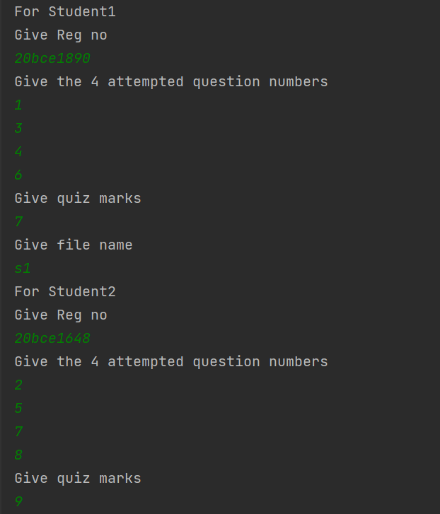

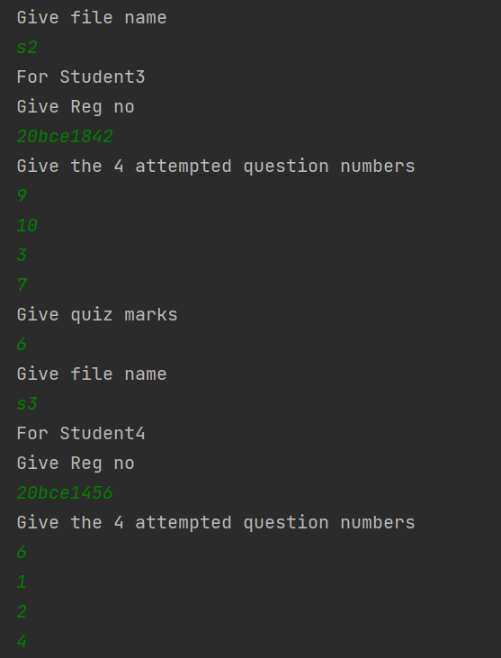

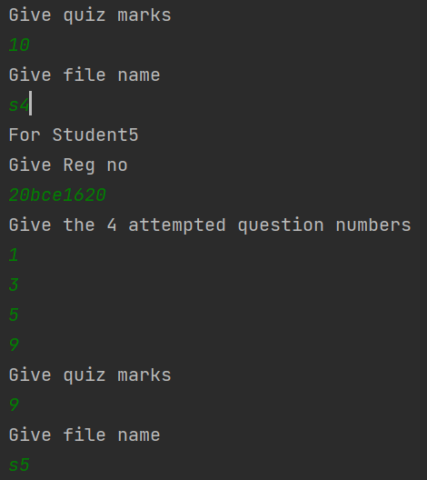

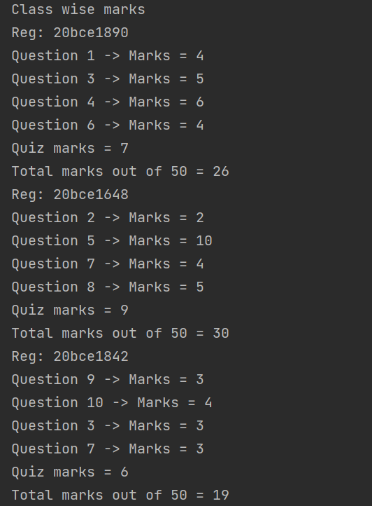 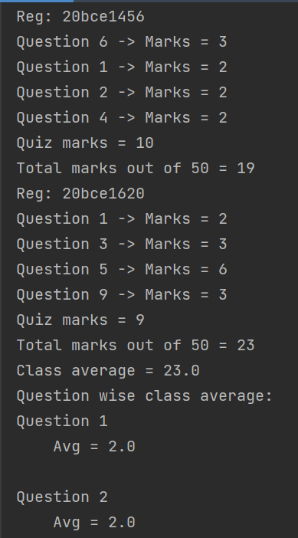

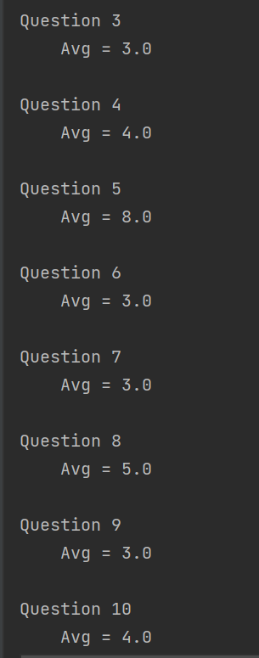

Thus we can see that every functionalies work properly.